### *BOA Consumer Complaints Dashboard Analysis*

### *Project Introduction:*

This Project focuses on the analysis of consumer complaints on the products of Bank of America. Bank Of America is one the largest banking institutions in America.Currently, this organization is operating in more than 35 countries. Consumer complaint records between 2017 and 2023 have been used for analysis.It intends to analyze consumer complaints and develop actionable insights based on analysis

### *Problem Statement:*

Analyzing Bank consumer complaints aims to identify relevant issues affecting customers,enhancing overall service quality. By Examining patterns and trends, Improve customer satisfaction, and strengthen their reputation,fostering a more resilient and trustworthy banking environment

### *Objective:*

* To analyze and visualize consumer complaints data from the CFPB database to identify complaint volumes, trends, and resolution effectiveness by product, channel, and state.

### *Data Dictionary:*

**Field Description**

| Complaint ID | The unique identification number for a complaint |
| --- | --- |
| Submitted via | The name of the customer. |
| Date submitted | Contact information for customers. |
| Date received | Another contact detail for customers. |
| State | Explore a wide range of customer attributes for segmentation and analysis. |
| Product | The type of product the consumer identified in the complaint |
| Sub-product | The type of product the consumer identified in the complaint |
| Issue | The issue the consumer identified in the complaint (possible values are dependent on Product) |
| Sub-issue | The type of sub-product the consumer identified in the complaint (not all Products have Sub-products) |
| Company public response | The company's optional, public-facing response to a consumer's complaint.Companies can choose to select a response from a pre-set list of options that will be posted on the public database. For example, "Company believes the complaint is the result of an isolated error." |
| Company response to consumer | This is how the company responded. For example, "Closed with explanation." |
| Timely response? | Whether the company gave a timely response (Yes/No) |

### *Data Cleaning & Preparation:*

Before going to analysis, it is essential to ensure the dataset is clean and reliable. The data cleaning process involves handling missing values, correcting inconsistencies, and formatting the data for analysis.

I have used **Microsoft Excel** for Data Cleaning.

1. ***Checking For Duplicate Values:***

I have Checked Duplicate values in the data Using Ms Excel Based on the **Complaint id** Column

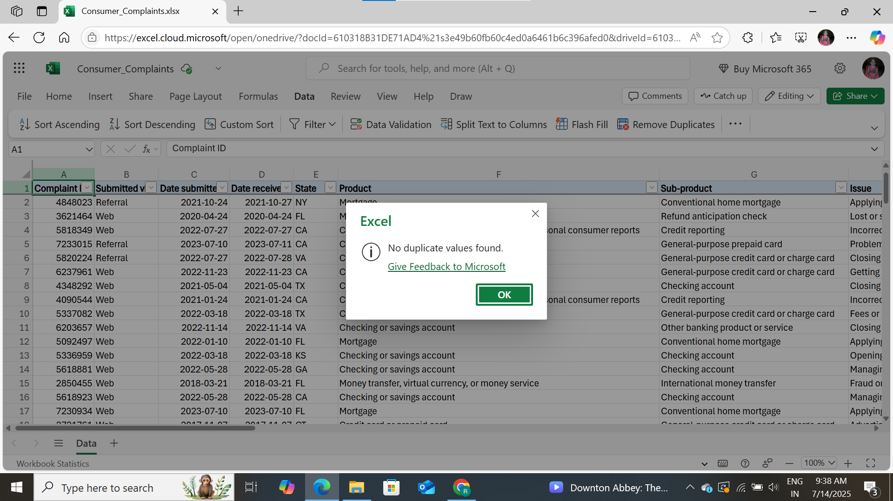

1. ***Handling Missing Values / Null Values***

If Missing Values are few we can remove, Otherwise we can label them as “Other” or “Unknown”.

I have Used the **COUNTBLANK** function to check the Missing values in the dataset

| **Column Name** | **No. Of Missing values** |
| --- | --- |
| Sub-Product | 7 |
| Sub-Issue | 10858 |
| Company public response | 255 |
| Timely Response | 160 |

* The **Sub-Product** Column has only 7 Missing values so we can remove it.

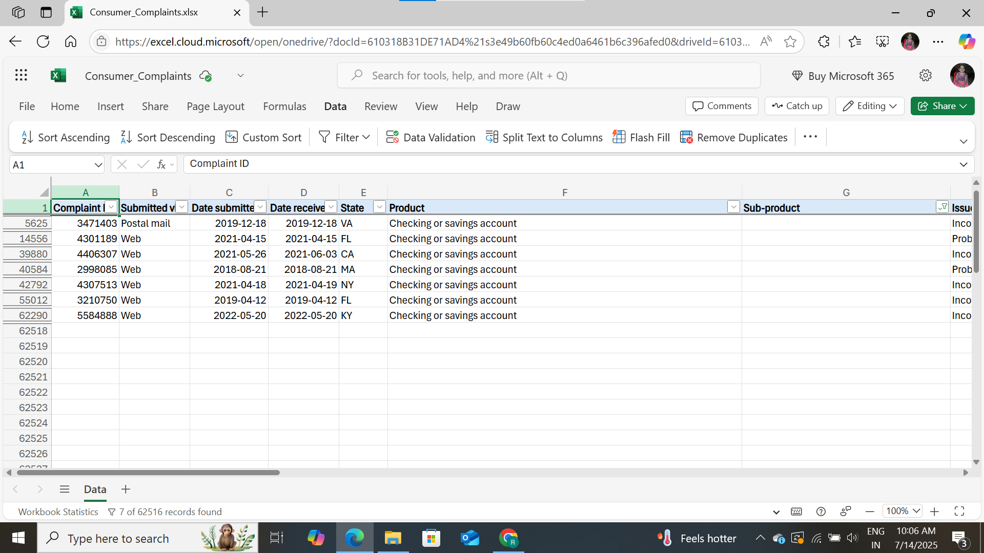

* The **Sub-Issue** Column has **10858** Missing Values. If we can remove these missing values this will impact the result so we can label it as **“Unknown”.**

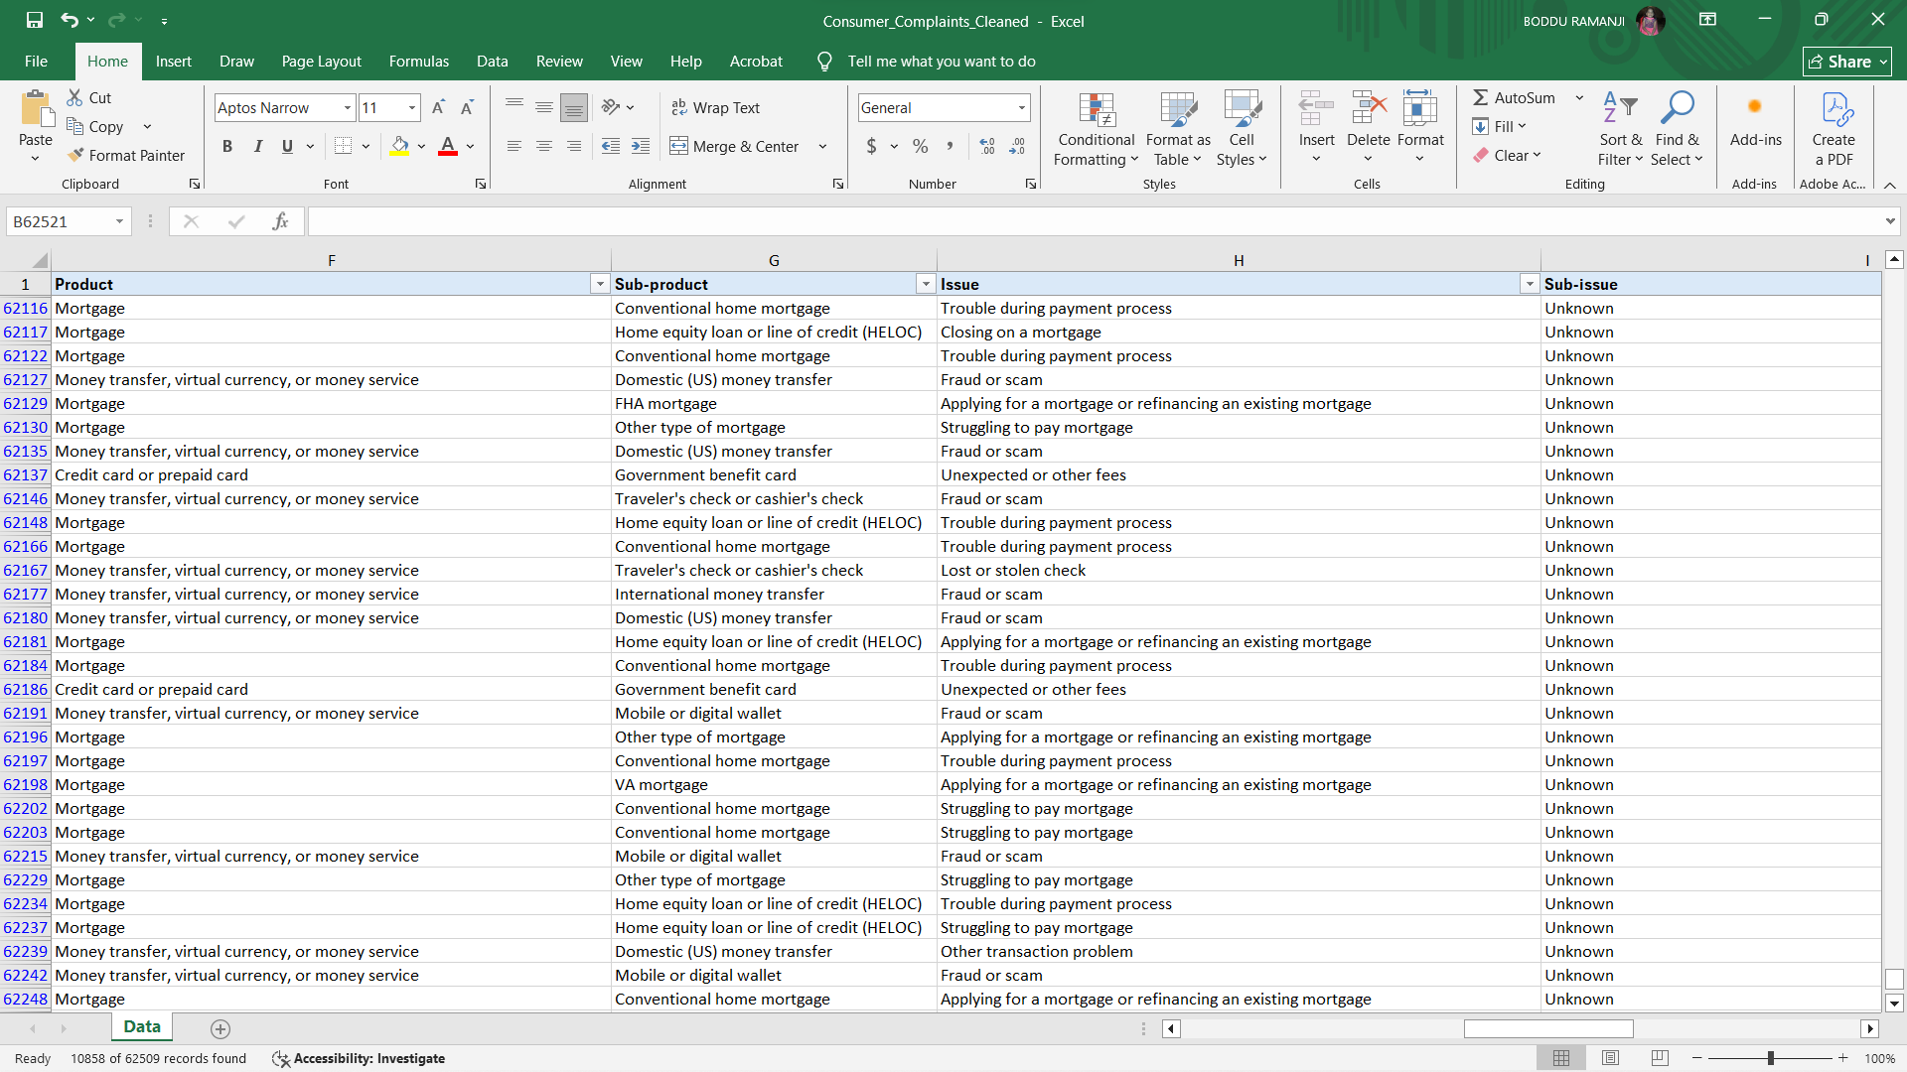

* **Company public response** has **255** Blank Values. So we can labelled as “Others”

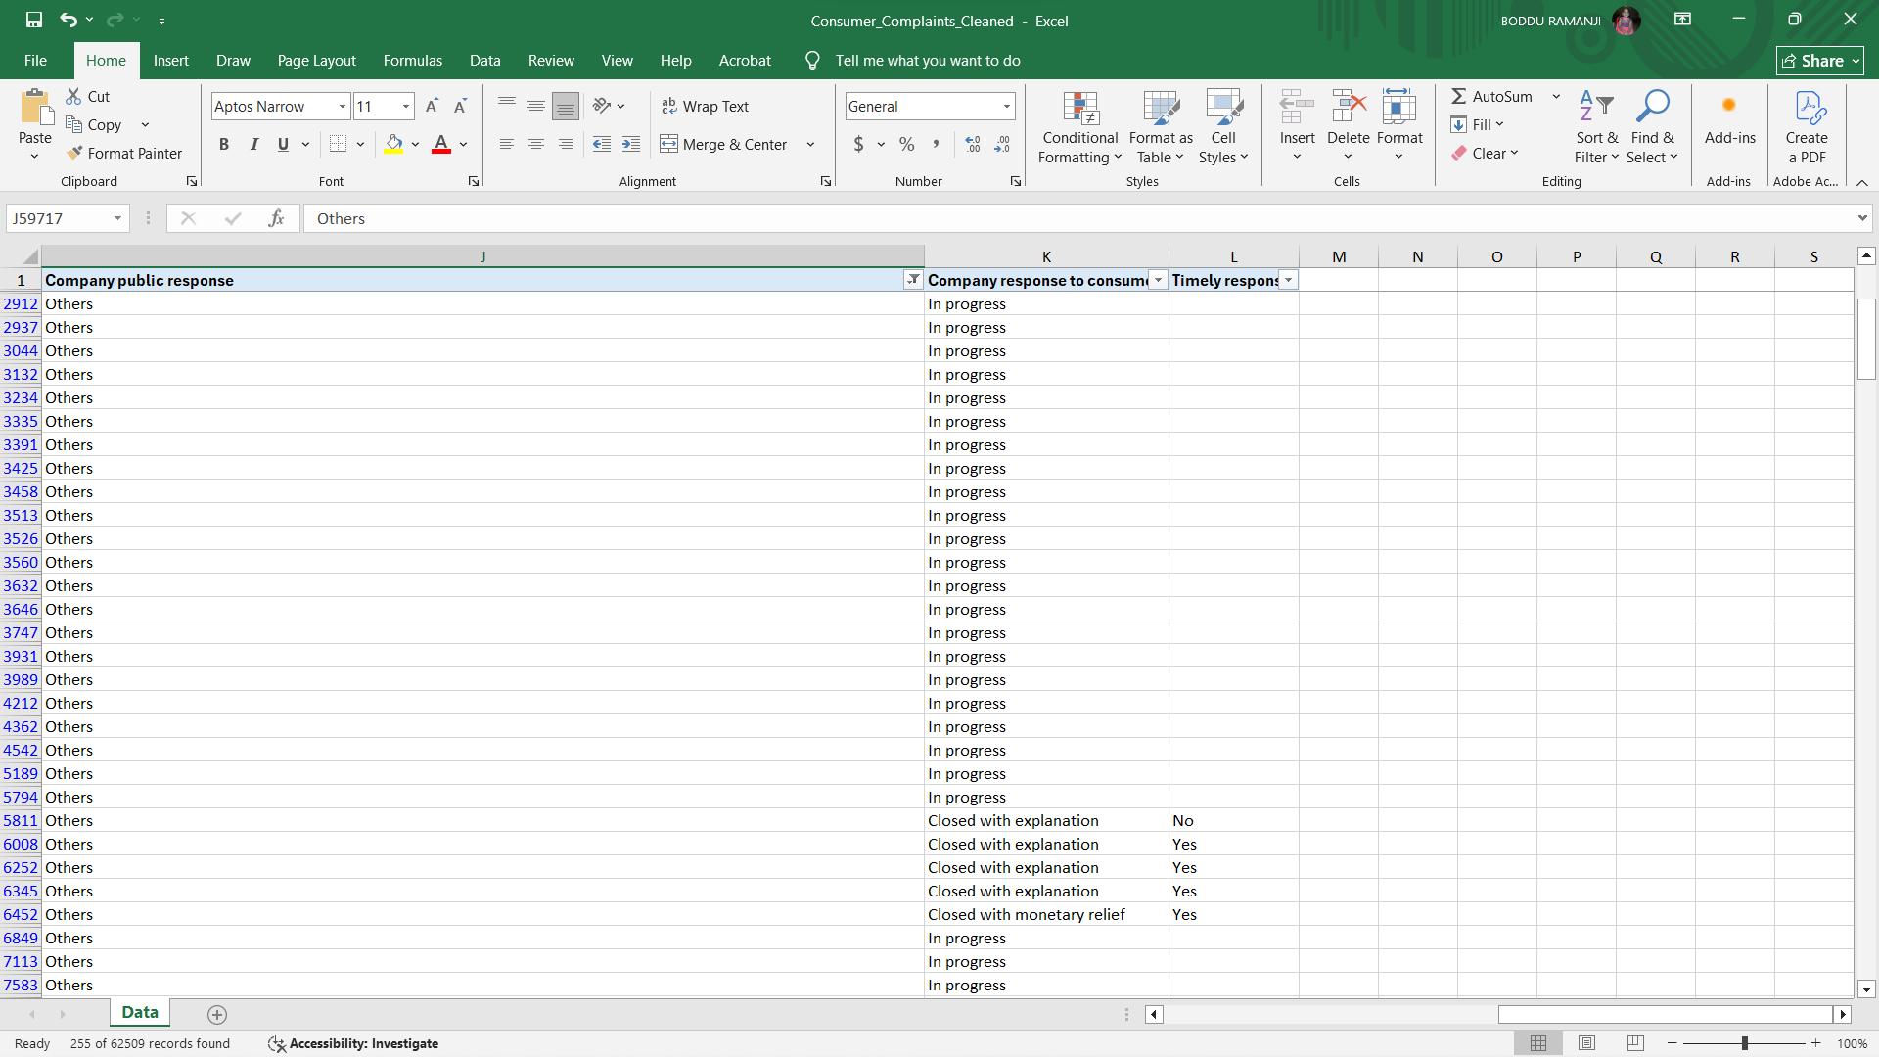

* **Timely Response** Column has **160 Blank Values**. So we can labelled as **“Unknown”**

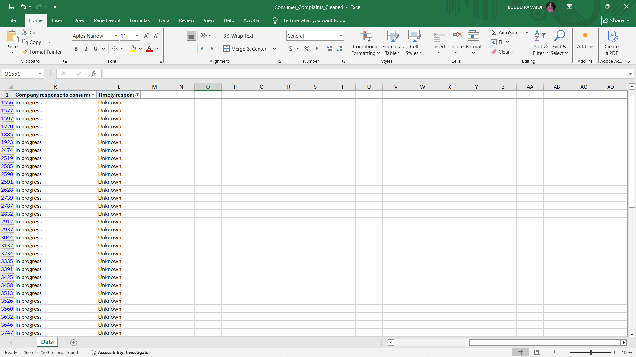

1. ***Standardize the Text Data***

I Standardized short-form names to full names (like changing “Alabama-AL”, “Alaska-AK”, “Arizona-AZ”) to make the data more readable and understandable.I have used **VLOOKUP** Function to mapping the State Short form code standard Codes

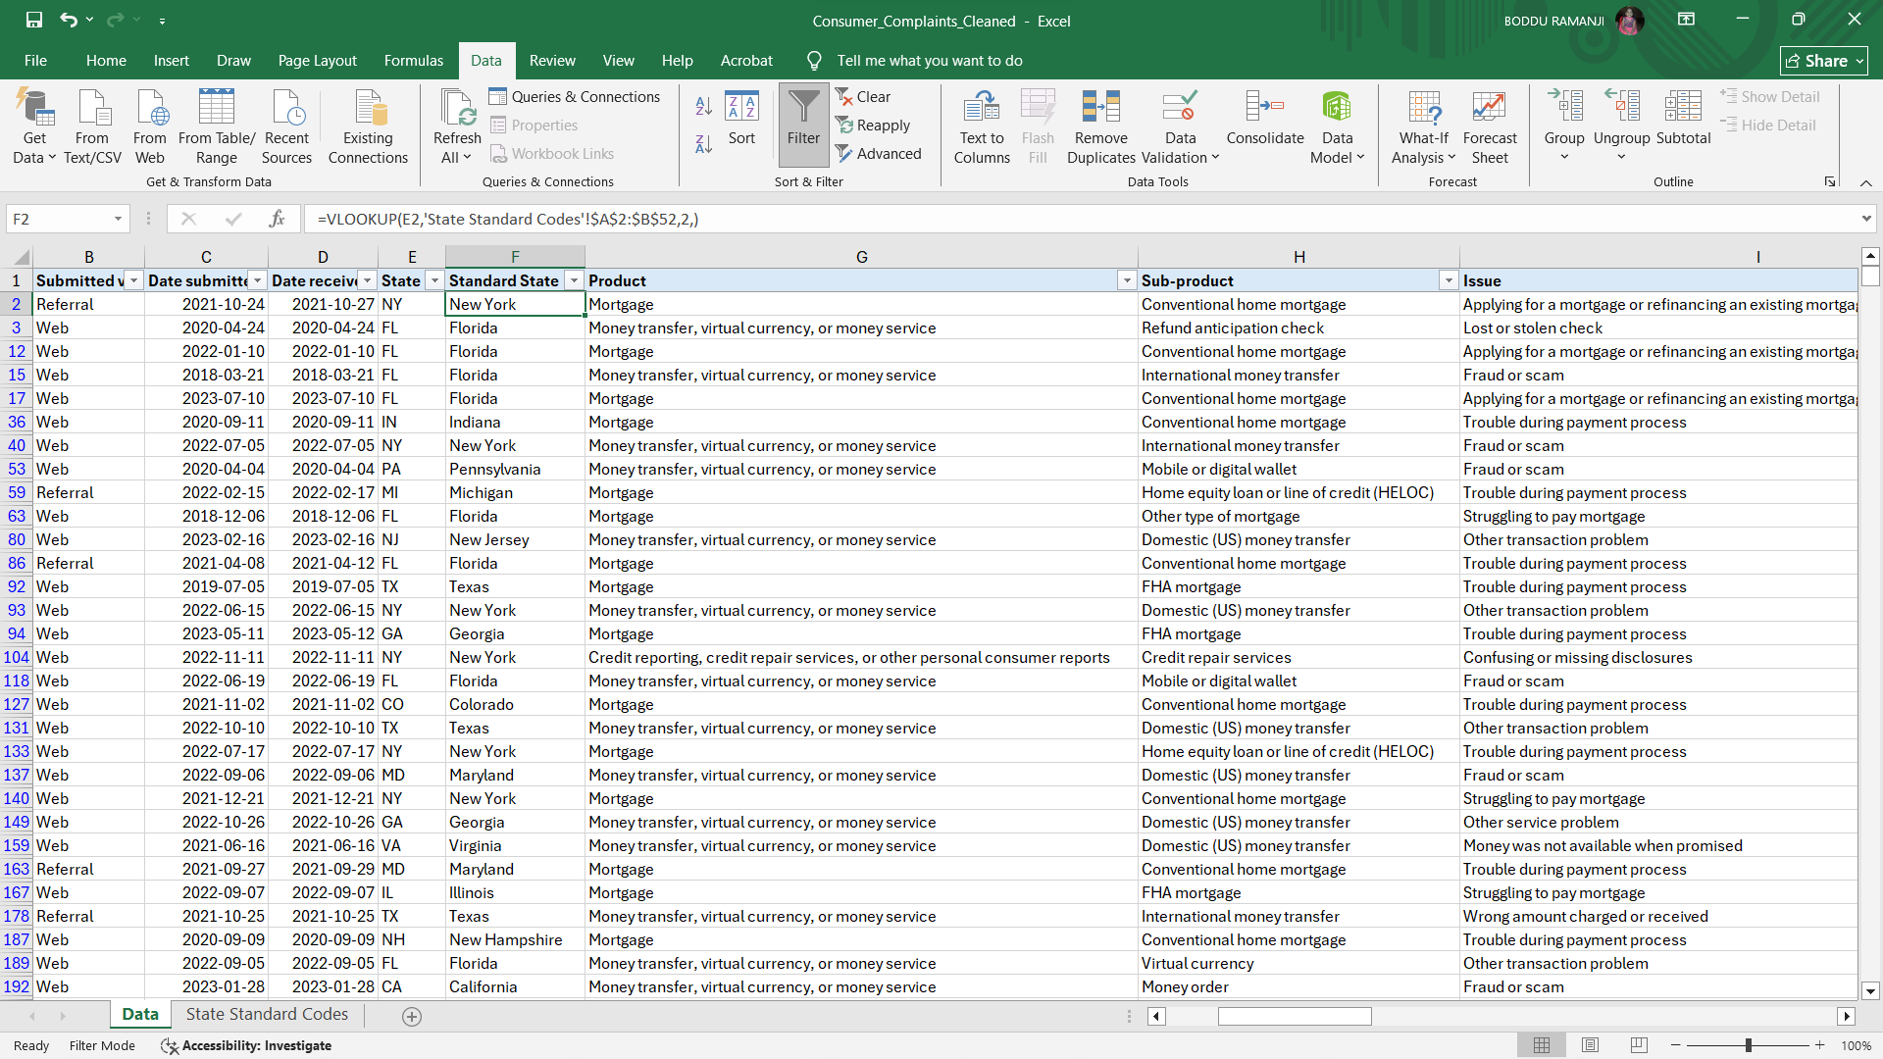

Finally I have transformed raw data into a consistent format suitable for Analysis.

### *Data Modeling:*

Tableau's data modeling involves structuring how data is connected and queried for analysis, using two main layers: the logical layer for relationships and the physical layer for joins and unions. Relationships, introduced in version 2020.2, allow for flexible multi-table analysis without merging tables, preserving their native level of detail. Joins and unions are used in the physical layer to combine data from multiple tables.

In this dashboard I have used a logical data model to connect **Consumer_complaints** table and **State Standard_codes.**The purpose of the Data Model is “Ensures Consistent State Abbreviation Mapping Across Dashboards”

I have created Relationship based on Condition

Consumer_Complaints[State] = State_Standard_Codes[State Name]

### *Dashboard Creation & Visualizations*

***KPI’s***

I have created KPI’s as following

- **Total Complaints = COUNTD([Complaint ID])**

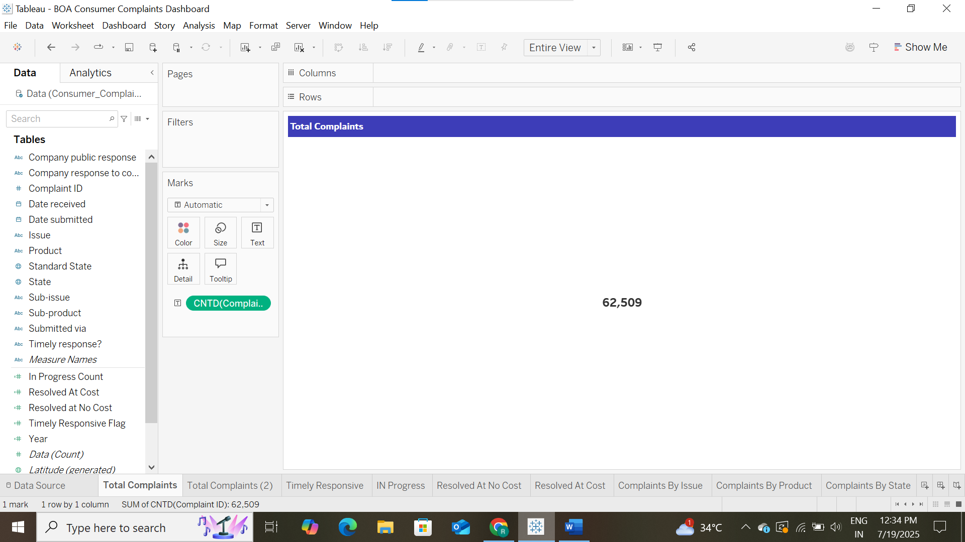

- **Count of Timely Responsive**

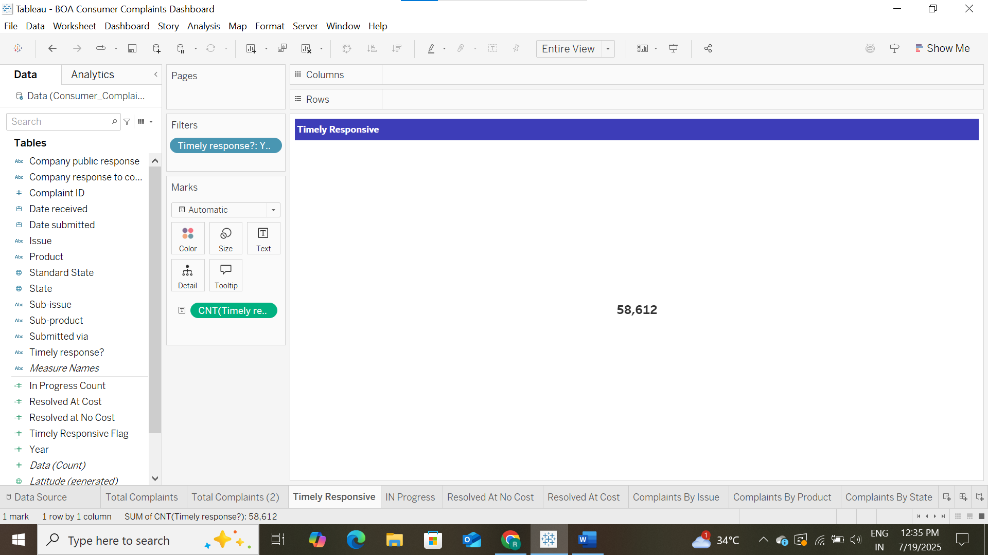

- **In Progress Count**



**- Resolve at No Cost**

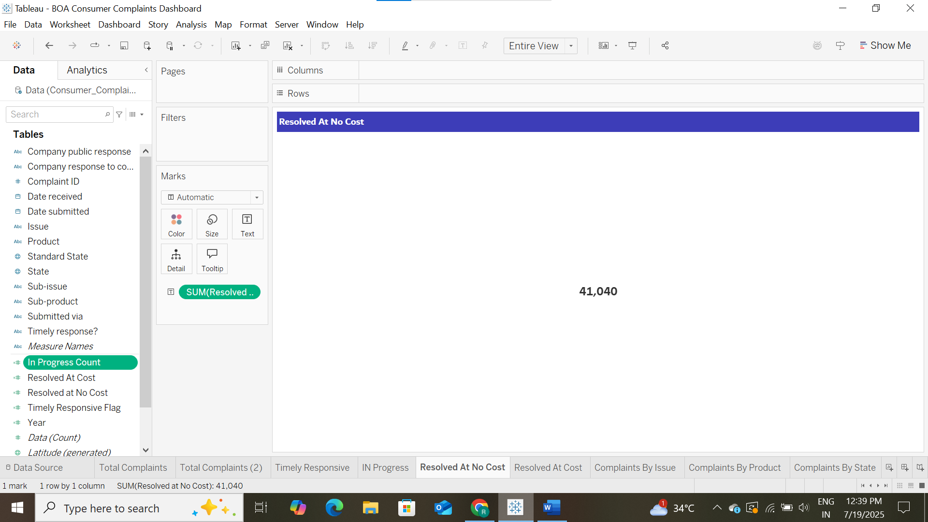

- Resolve at Cost

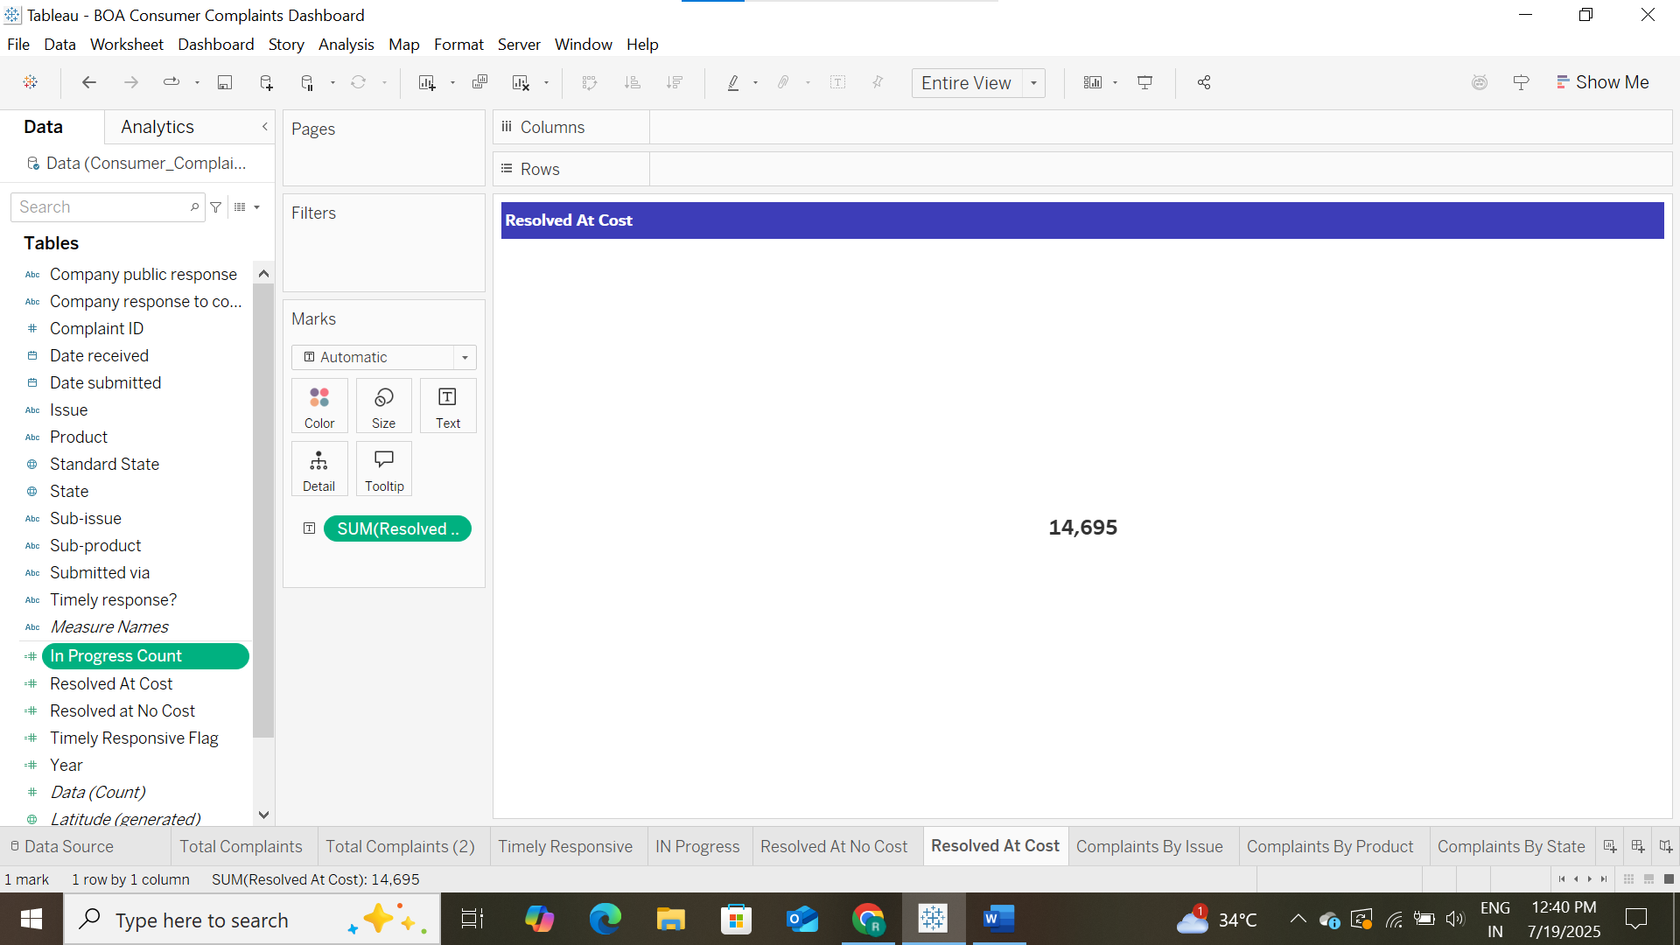

**Visualization Charts**

1. **Complaints By Issue**

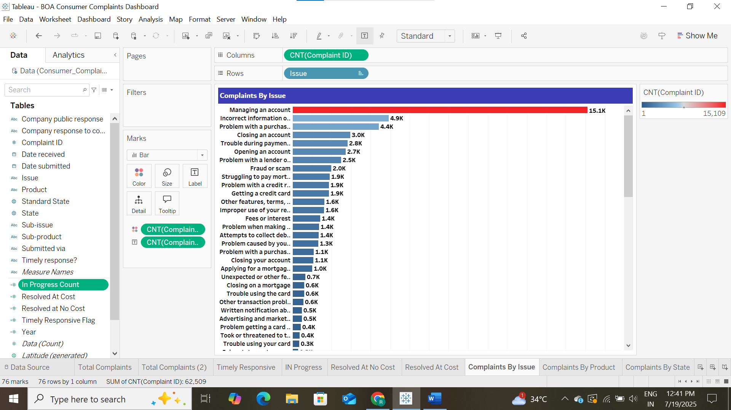

1. **Complaints By Product**

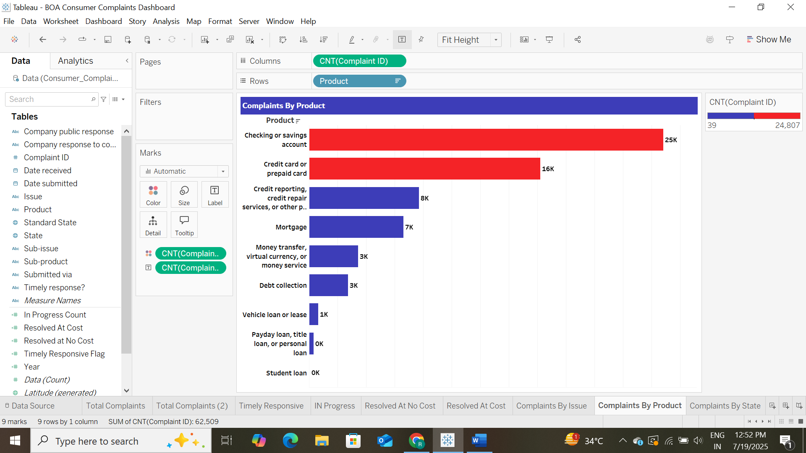

1. **Complaints By State**

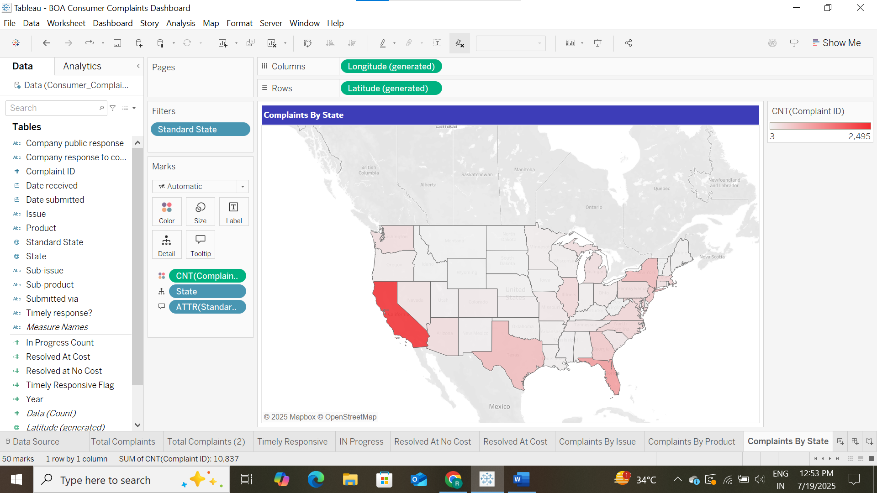

1. **Complaints By Media**

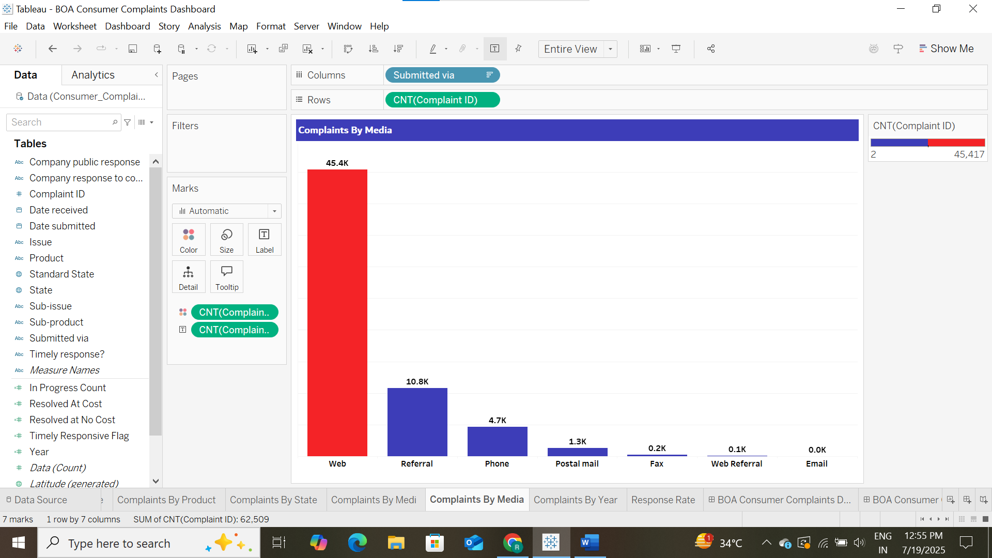

1. **Complaints By Year**

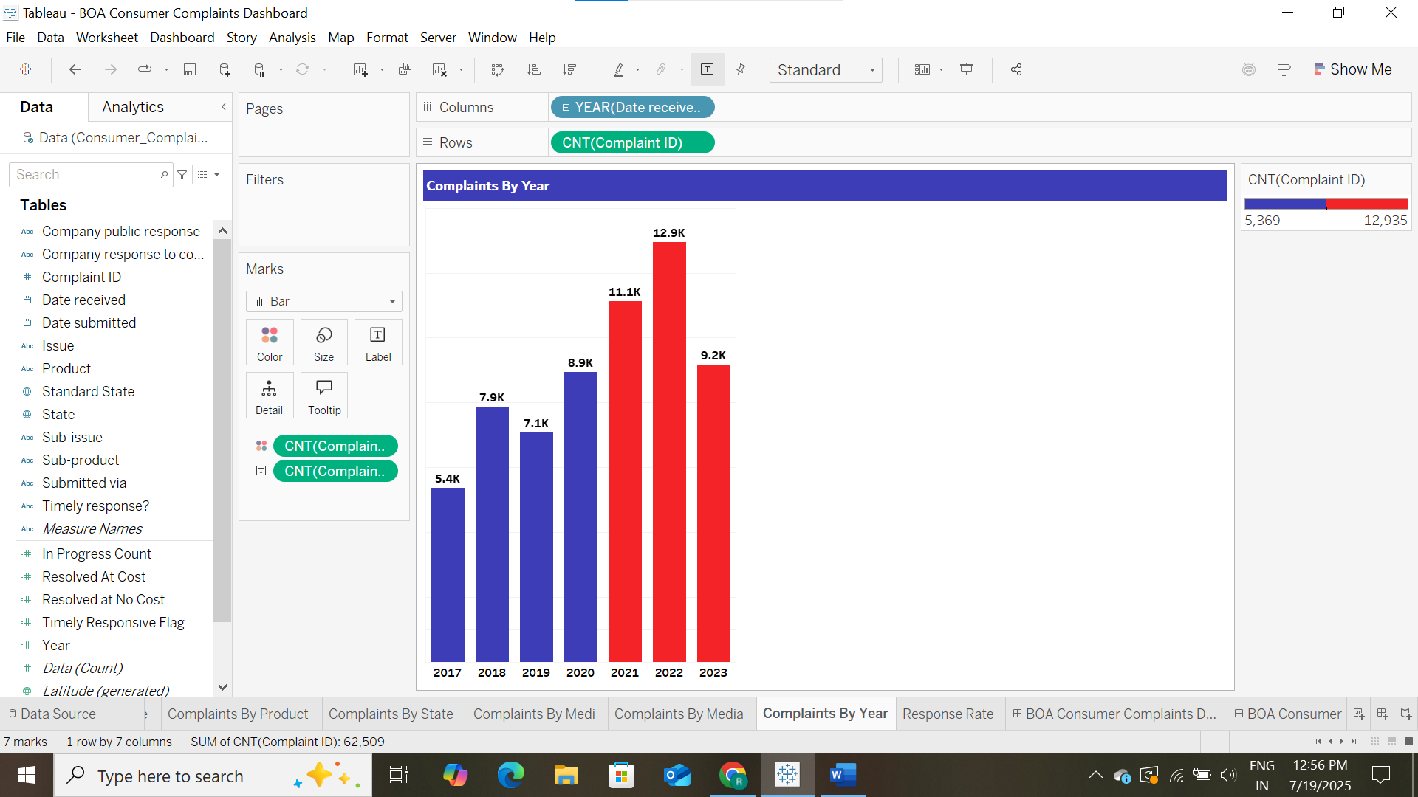

1. **Response Rate**

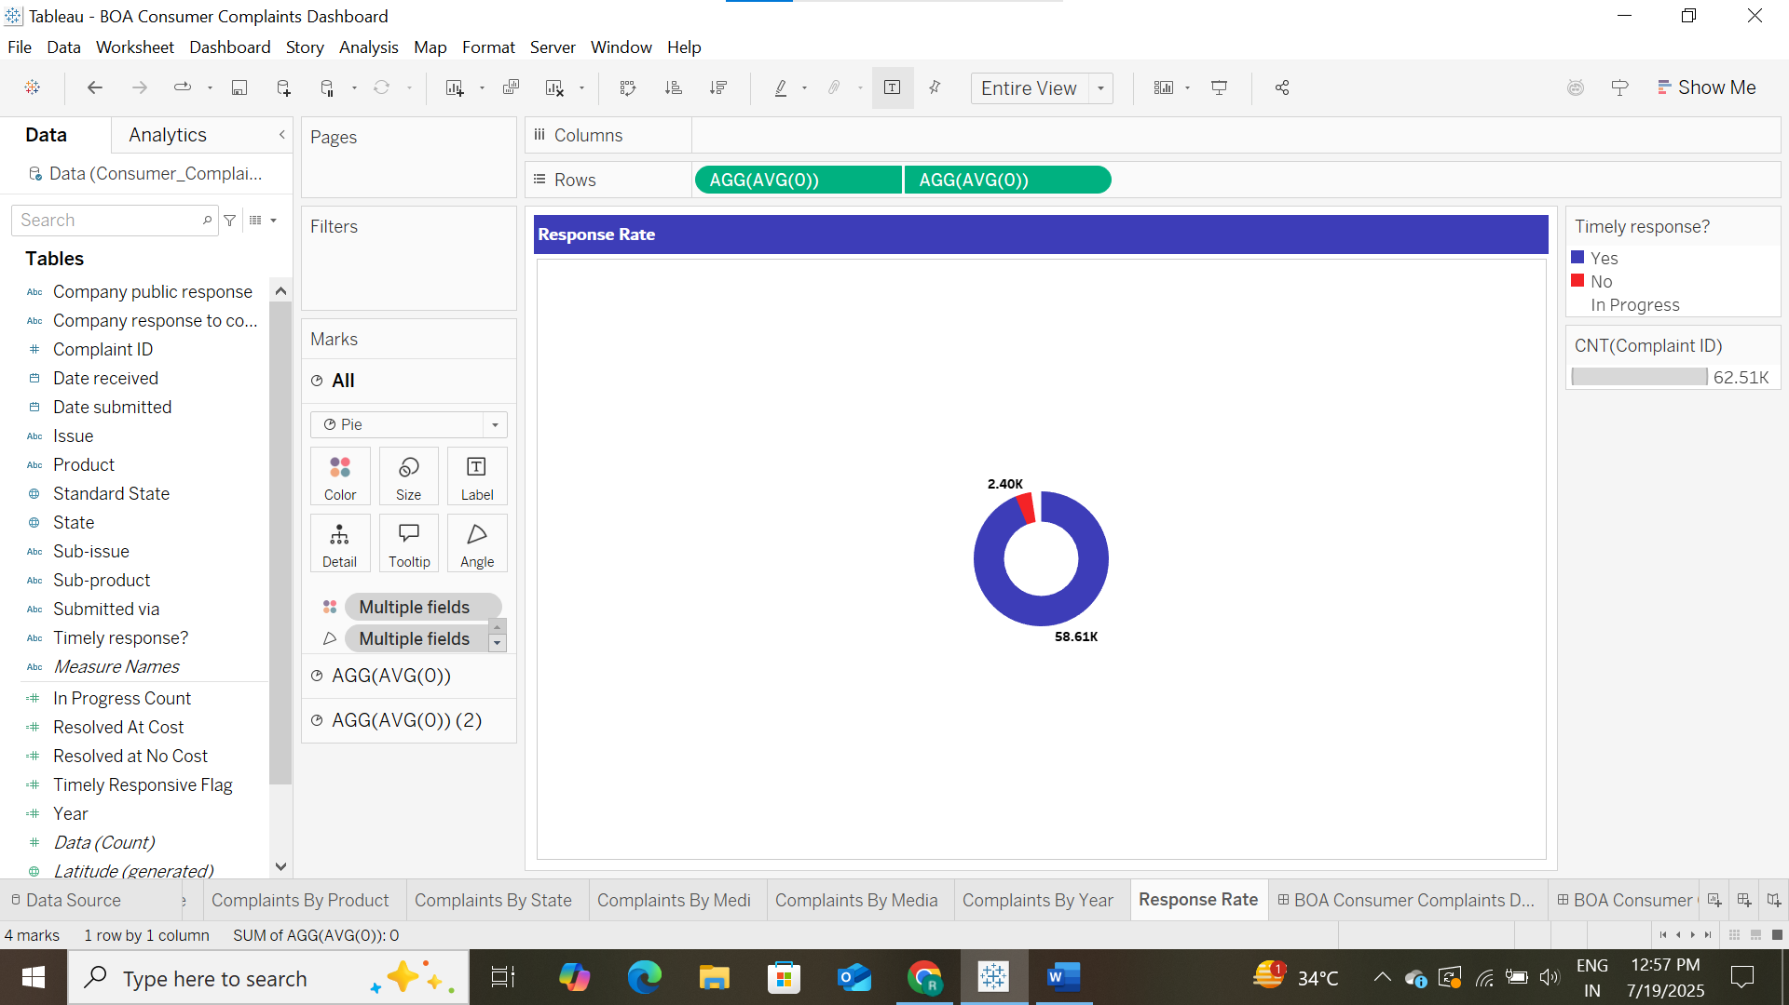

1. **Final Dashboard**

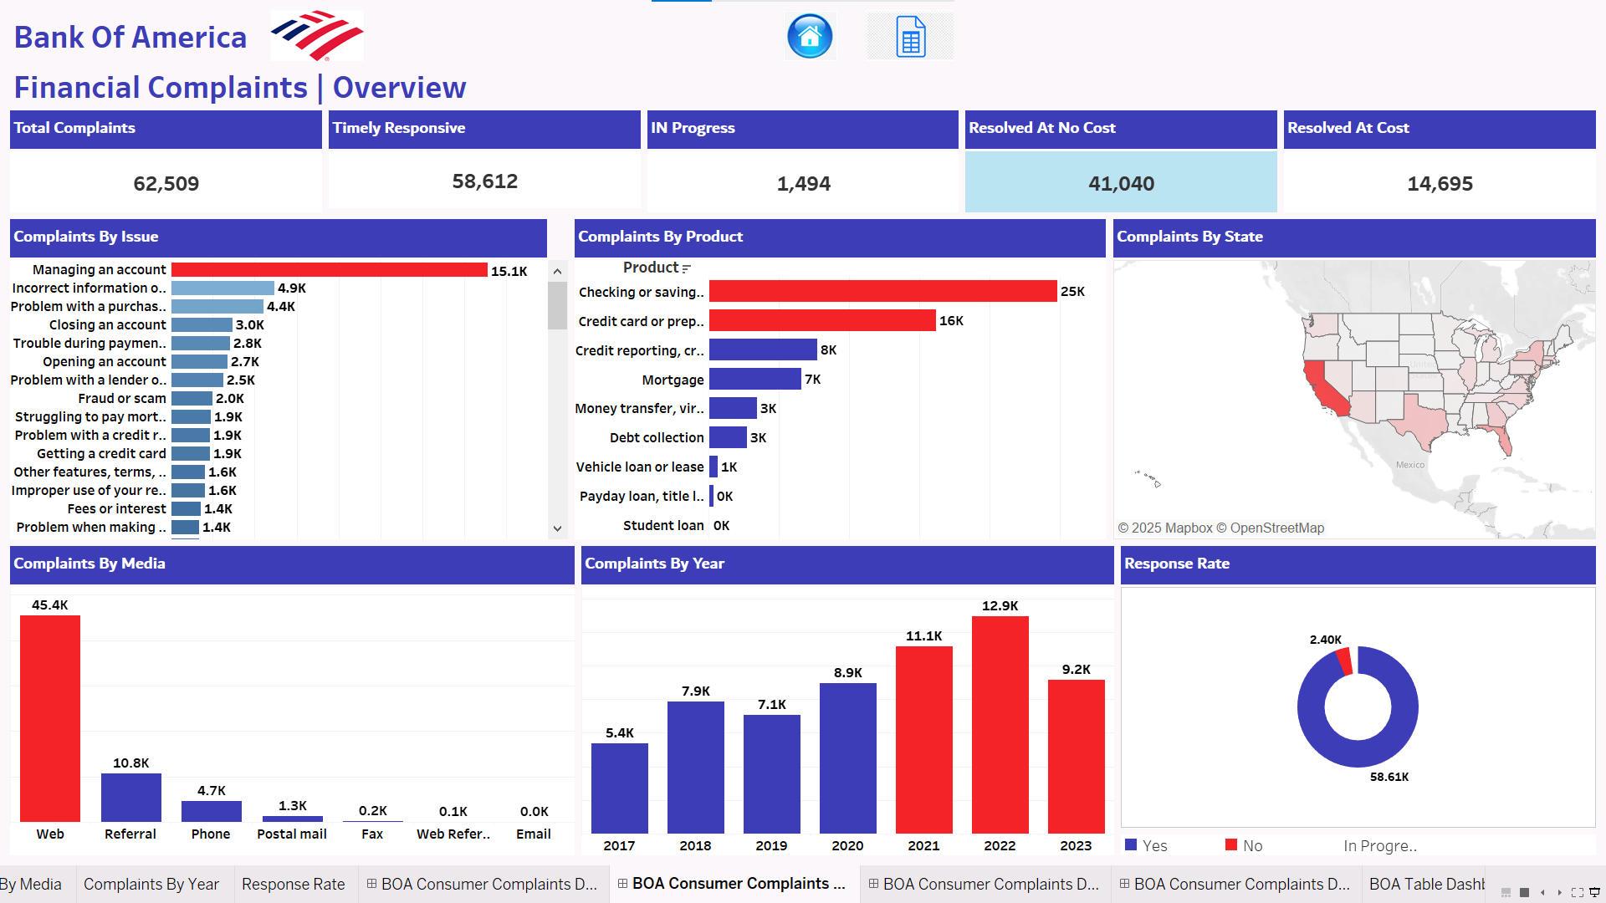

### *Insights Summary:*

* Most complaints were about **Checking or Savings Account** and **submitted via Web**.
* **California** and **Texas** had the highest complaint volumes.
* **Yearly complaints** peaked in **2022**.
* Total Response rate is **59K** Approximately
* Most Complaints Raised in **Managing Account**